**Daily Log Sheet: 27958-Hemanth Devaraj**

**Day-1: Topics Covered**

**Linux Introduction and Linux Commands :**

mkdir test_folder : create a new directory named test_folder

cd test_folder : change directory to test_folder

touch file1.txt : create an empty file named “file1.txt”.

echo “This is a new file” > file1.txt : prints the text inside the file named “file1.txt” .

cat file1.txt : read the content and display it on terminal.

ls :”shows all the list of files and directories.

mv file1 files : moves the file to a folder

history : shows all the earlier commands.

mv has two things to do one is to add a file to the folder or rename the existing file.

control + o is used to save the file

control + x is used to move out of the file.

Nano and vim are editors that are used for editing the content

cp command is used to copy the contents of a folder/file to another file/folder

cp -r is used to copy contents of a file or folder to another file or folder

historu>out.txt is used to save the history into a file as input

“>” this allows to add something from source to destination but the destination is overridden by the contents of the source

“>>” to get rid of this overriding we use this sign. This doesn’t delete the content of the destination file .

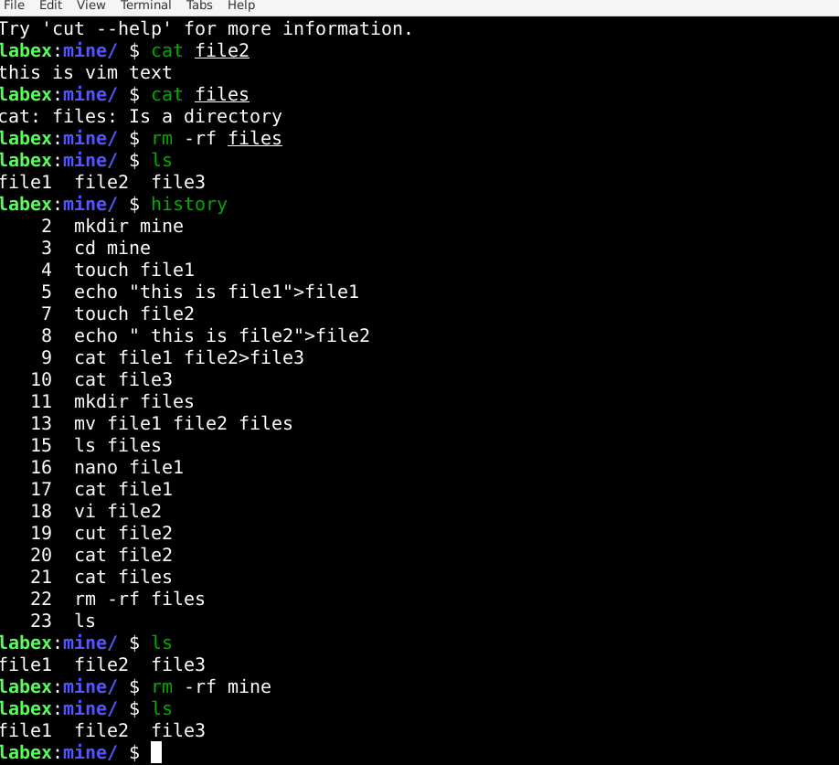

**Shell Scripting:**

shell scripting is nothing but writing a series of commands for a shell to execute automatically one after other.

It uses commands like ls,cd,mkdir etc

Its file extensions is .sh  
 we need to provide permission to run a script

Usually we use chmod +x filename.sh

Chmod is used for change mode ie used to change permissions   
+x is add executable that means files can be executed like a program.

Then to run the script we use “./filename.sh” command.  
  
  
**Codes executed using shell script:**

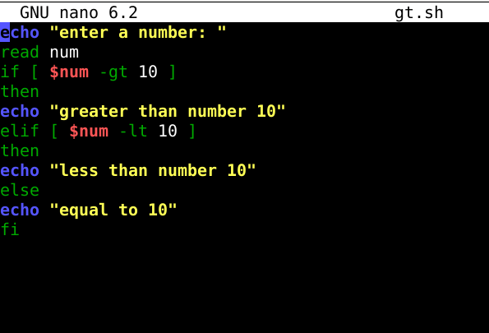

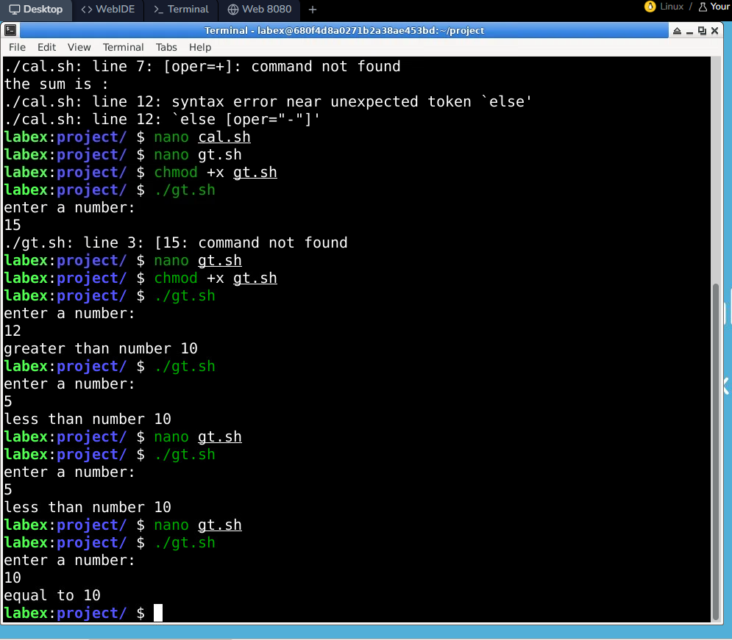

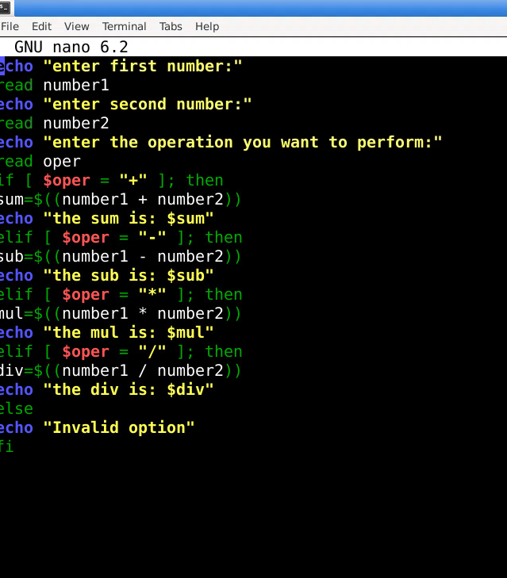

**Day 2: Topics Covered:**

**Number Systems:**

A number system is a way to represent numbers using symbols and digits

We basically have 4 different types of number systems : Decimal, Binary, Octal and Hexadeciamal

* Decimal: It has base value as 10. Digits used are from 0-9
* Binary: It has base value as 2. It uses 0 and 1 digits. It is mainly used by computers
* Octal: It has base value as 8. It uses digits from 0-7
* Hexadecimal:It has base value as 16. It uses digits from 0-9 and A-F(A-10, B-11,C-12, D-13, E-14, F-15)

Conversions of Number Systems:

1. Binary to Decimal: Multiply each binary digit by its place value (power of 2) and add. 1011 -> (1 × 2³) + (0 × 2²) + (1 × 2¹) + (1 × 2⁰) ie 8+0+2+1=11
2. Binary to octal: Divide the binary value into 3 groups from right to left.
3. Binary to Hexadecimal: Group binary digits in 4 bits from right to left. Then convert each group into a Hex digit. Example:11010110->1101(D) 0110(6) ie D6
4. Decimal to any: We need to keep dividing by the base of the number we need to convert and then write remainder from bottom to top.
5. Octal to Binary: Convert each digit of octal number into an equivalent group of three binary digits. (57)base8->101 111 ->( 101111)base2
6. Octal to decimal: Multiply each digit of the Octal number with the place value of that digit, starting from right to left.

Example: (127)base8->1 × 8² + 2 × 8¹ + 7 × 8⁰=64+16+7=87

1. Octal to hexadecimal: : Convert the octal into binary and divide the binary number into four groups from right to left.

Ex:(145)base8->001 100 101->0000 1100 0101->1100 0101->C5

1. Hexadecimal to binary: Convert the hexadecimal into decimal and again convert the decimal into equivalent group of 4 binary digits.

Ex: (2F)

1. Hexadecimal to decimal: Multiply each digit of the hexadecimal number with the place value of that digit, starting from right to left.
2. Hexadecimal to octal: Convert to binary and then divide the binary number into three groups from right to left.

Quiz:

1.A-10

2.A-2

3.A-15

4.B-1002

5.A-15

6.B-42

7.A-1000000

8.A-13

9.C-16

10.C-3F

11.A-FF

12.A-F

13.A-1010

14.B-0-7

15.A-10

16.D-11100

17.A-78

18.A-22

19.A-Decimal

20.A-Ox

21.A-1011

22.A-1000000

23.A-111

24.A-12

25.A-26

26.A-9

27.C-12

28.A-10

29.B-0b110

30.A-1100

31.A-1100100

32.A-1111

33.A-111111

34.D-0F

35.A-101

36.A-Hexadecimal

37.A-8

38.A-15

39.A-16

**SQL:**

It is structured Query language .It is Databse query language

Used for communication with databse

RDBMS-Relational DBMS.Mysql,oracle is Relational db server   
here we manage relational databases

SQL queries

DQL-Data query language (select)

DDL-Data Defination language (create, alter,drop, truncate)  
DML- Data Manipulation Language(insert, update, delete)

DCL-Data Control Language (Grant,revoke)  
TCL-Transaction Control Language(commit,rollback,savepoint)

Select- to select the data we want from the table

*-to bring all the items from the table

Where command-condition and op

To create/add columns new data we use insert

To update /modify data in the table we use UPDATE command

Select * from customer

UPDATE customer

SET age=30

WHERE name=’Vikram’  
SET SQl_SAFE_UPDATES=0;

To delete:

DELETE FROM customer

WHERE customer_id=7;  
  
SELECT * FROM customers ORDER BY age DESC;  
TO create a new table:

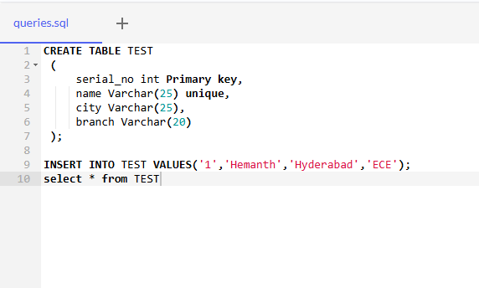

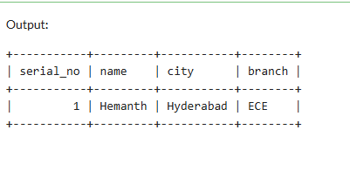

To alter the data in the table ie to modify the data in the table we use ALTER command   
example query

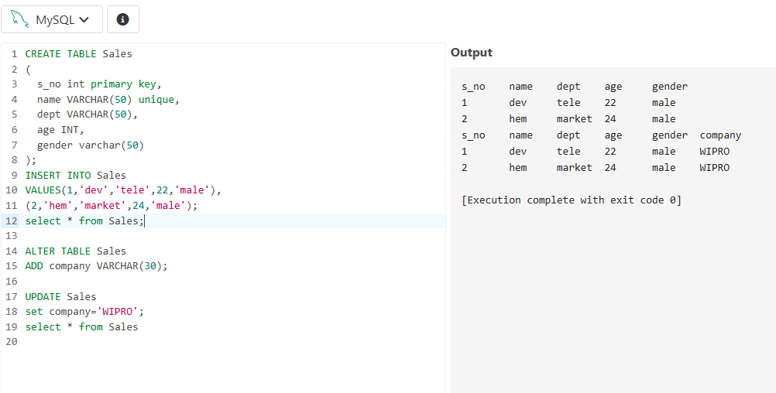

To get huge data or to import data into our database we use csv files.. only this extensions files can be used for databses.

So here is an example code of importing csv file and running the query

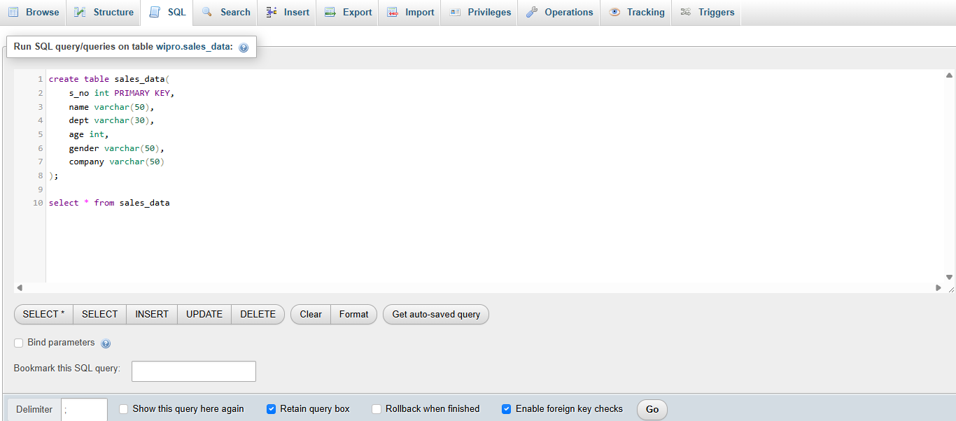

After creating this table now import the csv file to this and run the query   
 select * from sales_data   
after this we get output of the data present in csv file .output is

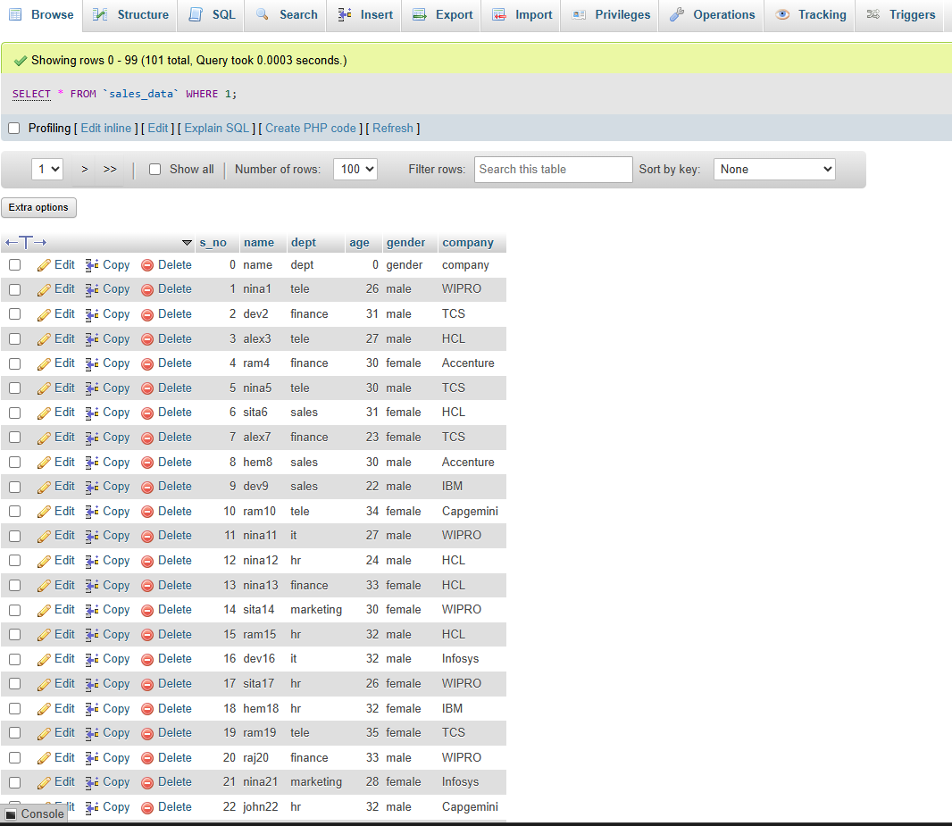

**TASK OF THE DAY:**

CREATE A TABLE TO FIND THOSE WHOSE NAMES IS STARTING WITH S AND ENDING WITH M AND ALSO FIND WHOSE AGE IS >9 AND <19…  
  
Here I have created an employee table and gave table name as emp and gave entry data and printed the table

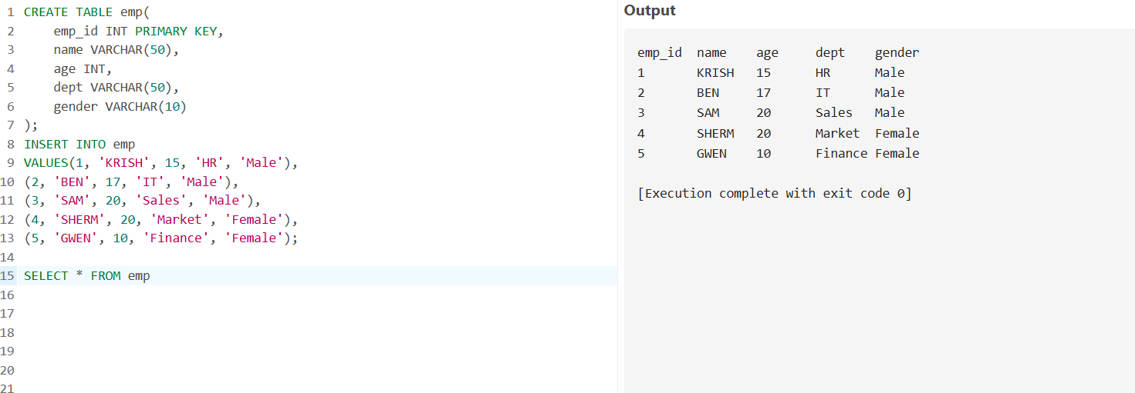

Then I gave the WHERE(condition) syntax to print the guys whose name starts with s and end with m , following is the query and the output

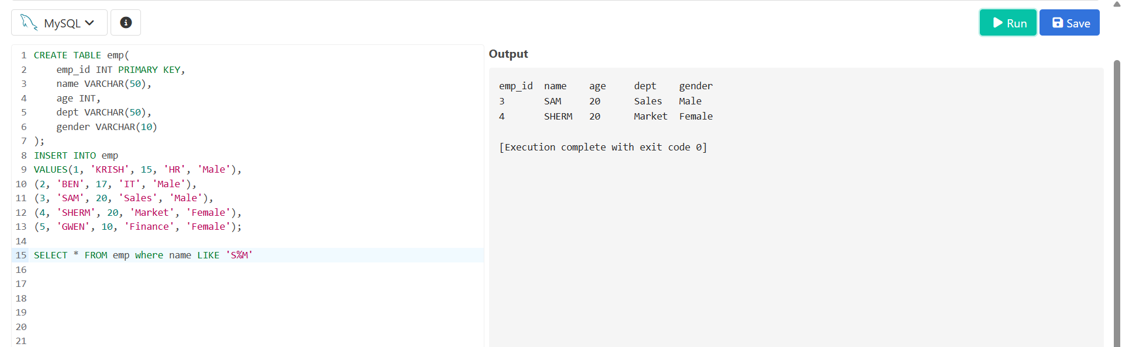

Then I gave the WHERE(condition) syntax to print the guys whose age is >9 and<19, following is the query and the output

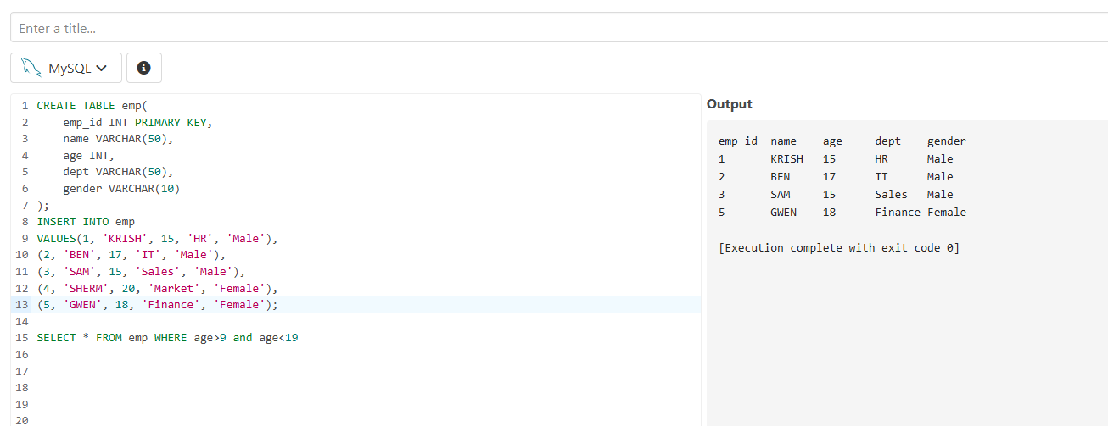

Now by executing the both given conditions here is the query and the output

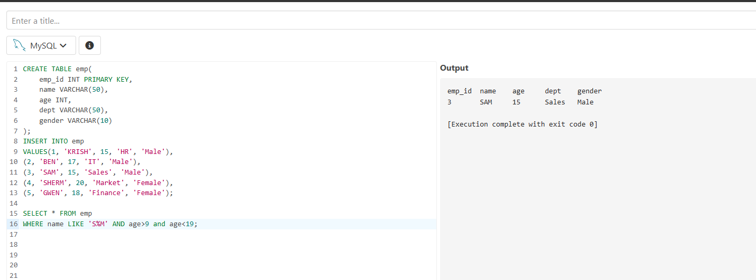

**DAY-3: TOPICS COVERED:**

Revised SQL commands   
setting up lab and installation of mysql workbench

**JOINS**

* Joins is an operation used for combining rows from two or more tables based on related column between them.
* We have different types of join they are   
  Inner join  
  left join  
  Right join  
  Full join(union of left and right)  
  cross join

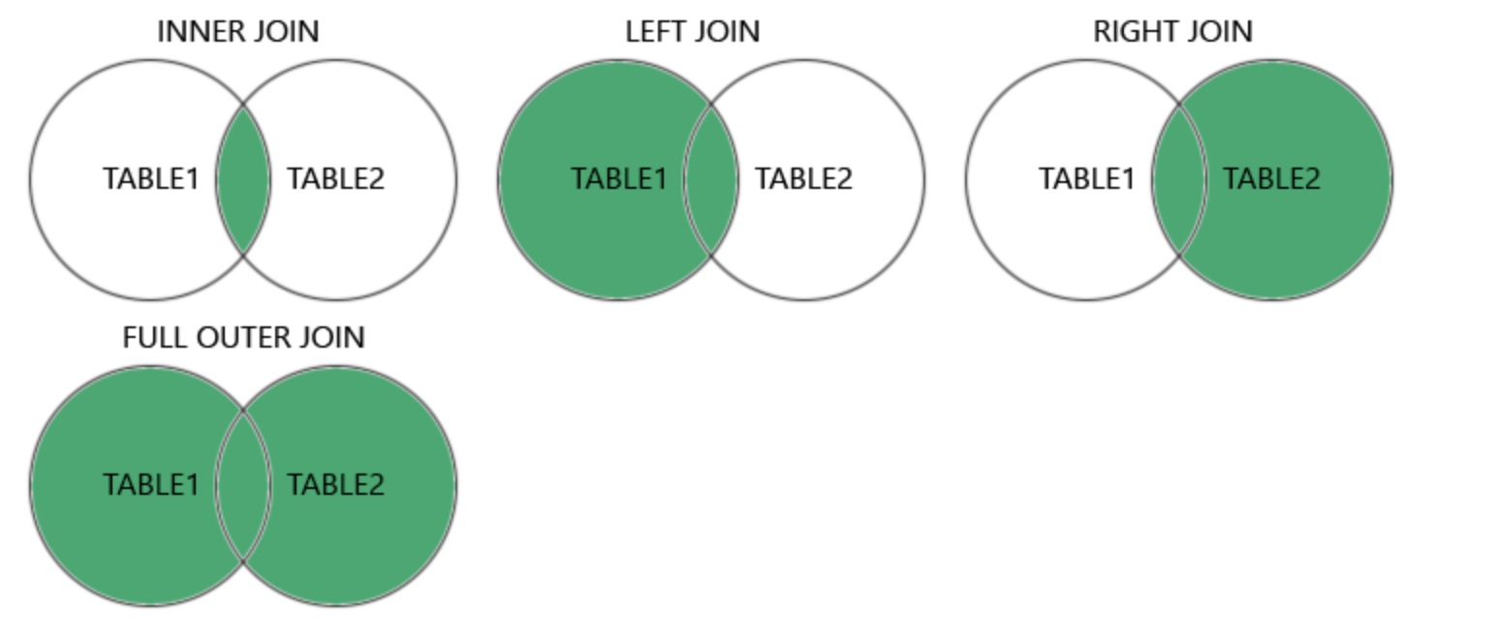

* To join any two tables we need to have atleast one col name as same
* To connect them we have a foreign key. It is nothing but it is a key that is connected to primary key of another table .
* **Inner join** only returns rows that have matching values in both the tables  
  we use INNER JOIN keyword to generate output
* **Left join** returns all rows from left table and matching rows from right table.we use LEFT JOIN.
* **Right join** returns all rows from right table and returns matching rows from left. we use RIGHT JOIN.
* **Full join** returns all rows from both the tables .we can use LEFT JOIN UNION RIGHT JOIN for full join.
* **Cross Join** returns every row from one table to every row to another table. No FK is required to perform cross join
* Here are the example codes for all the joins .
* Here is the sql query that is written for joints
* 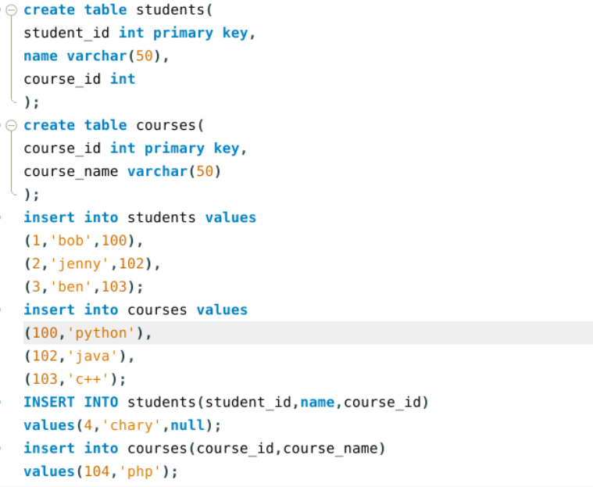
* Inner join:  
  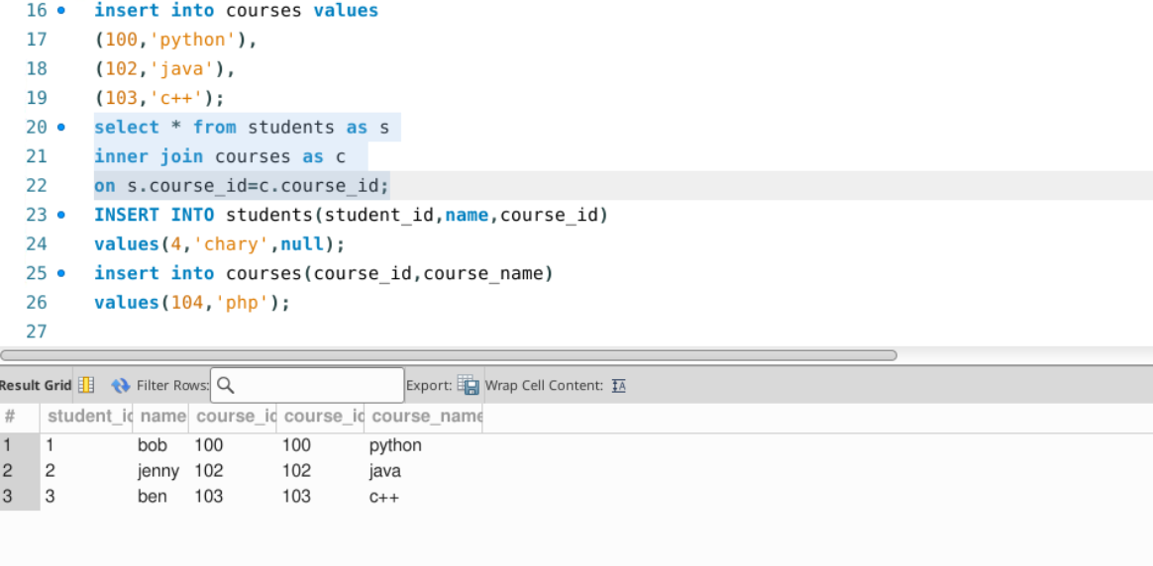
* **Left Join**

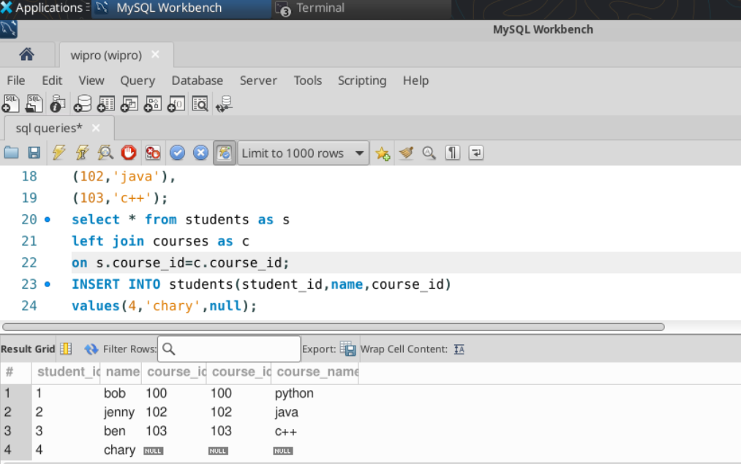

* **Right Join**

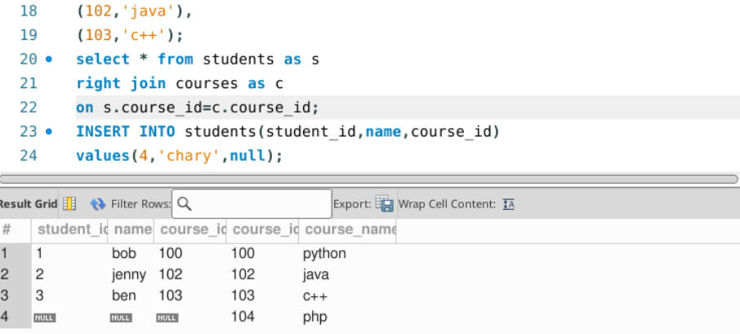

* **Cross Join**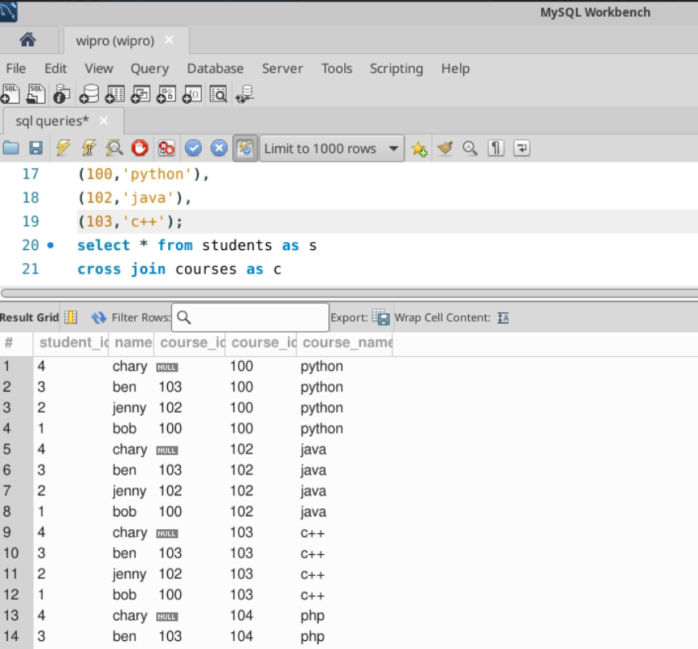
* **Full Join**

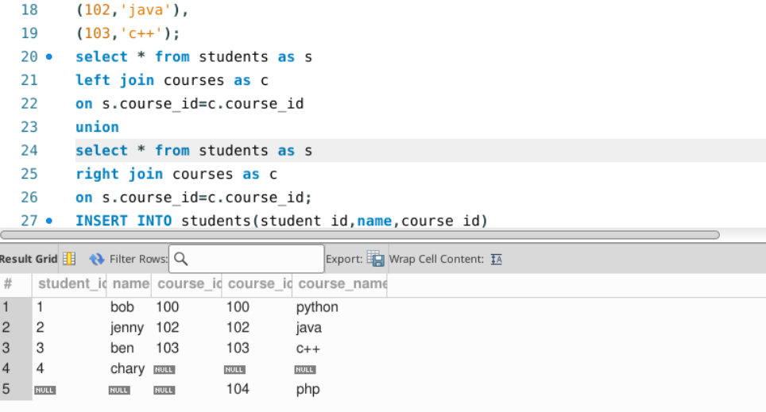

* We have two conditions mainly in joins they are where and on
* Where is used after the join
* On is a condition used in joins
* To find unmatched rows among two tables we do

Select A*  
from tableA A  
left join tableB B on A.id=B.id  
where b.id is null

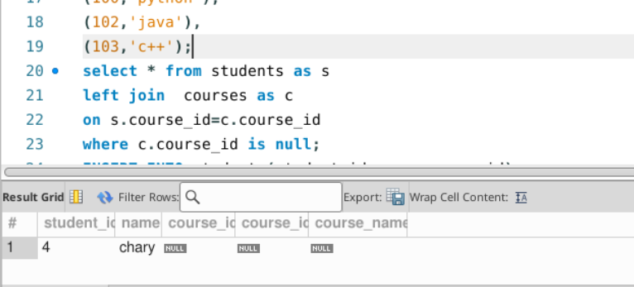

**TASK OF THE DAY:**

**We have to output all the students who are enrolled in course NMS “  
students –stid and name  
enrollments—stid and c_id  
courses---id ,name**

